1. What is the internet address of your computer?

172.20.10.3

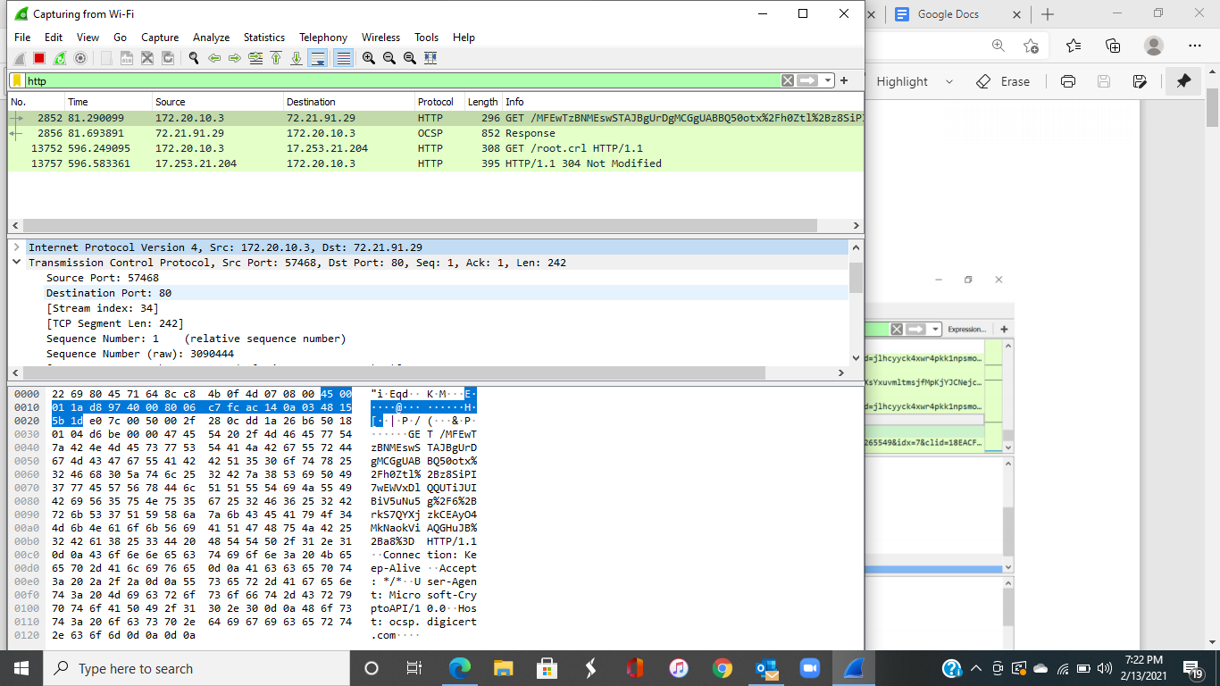

2. List 3 different protocols that appear in the protocol column?

HTTP, OCSP, PXIX

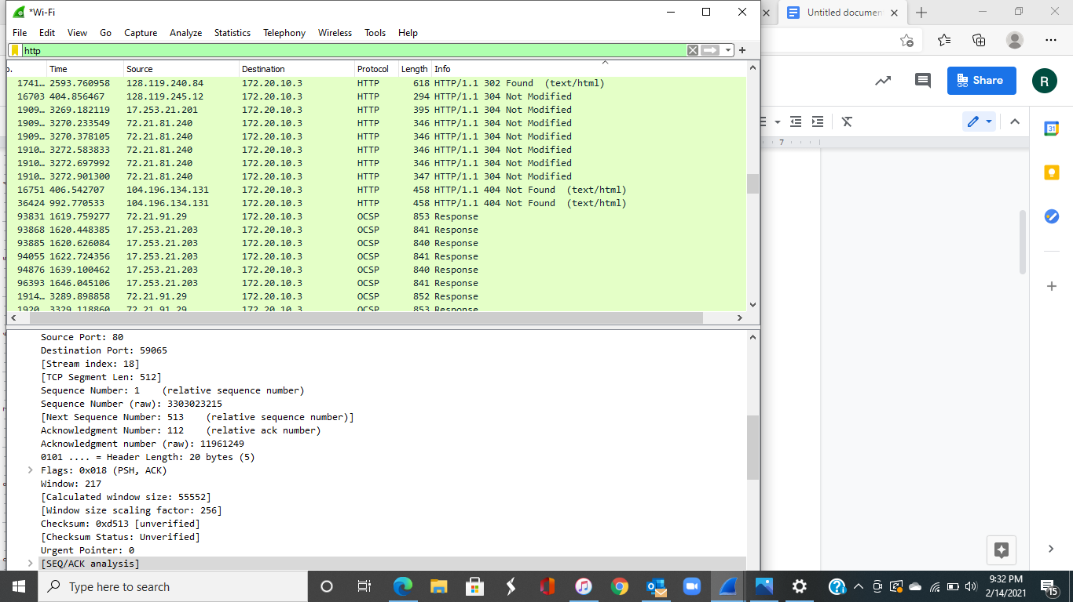

3. Arrival time of GET request is: 20:9:45:02.296783000

Arrival time of OK request is: 20:9:45:01.323751000

Difference: 0.323751000-0.296783000=0.026968sec

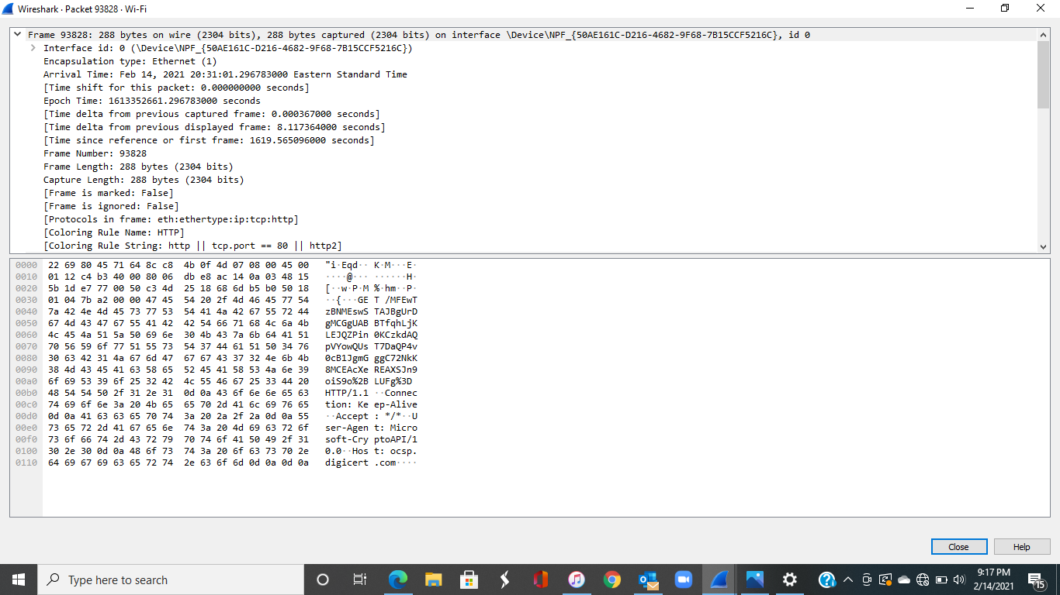

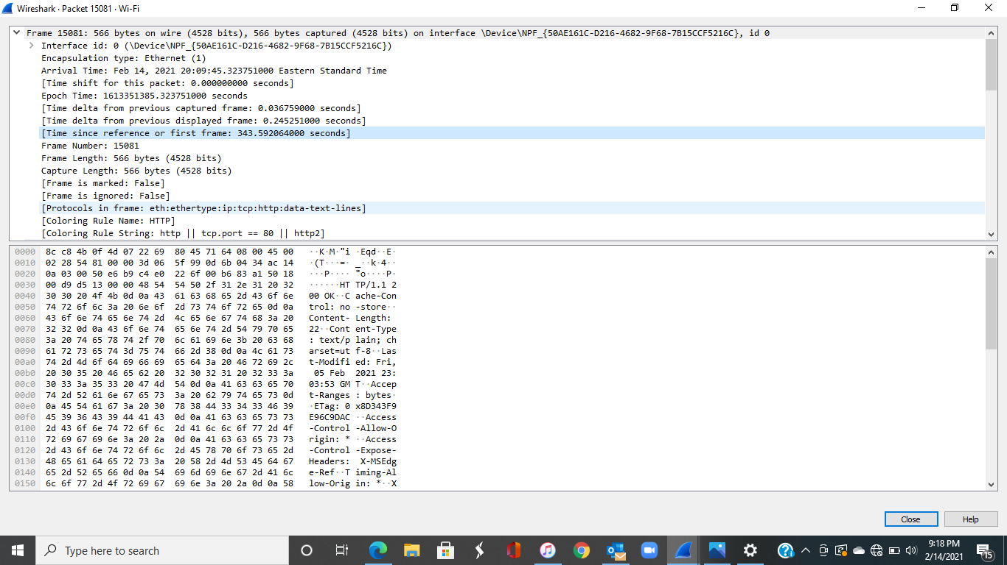

4. What is the Internet address of the gaia.cs.umass.edu?

72.21.91.29

